TRUSTEES ANNUAL REPORT AND FINANCIAL REPORT

of

BODLE STREET GREEN
VILLAGE HALL TRUST FUND
Charity Registration Number: 227875

For the year ended 31st DECEMBER 2019

CONTENTS

Page
Trustees Annual Report 2 - 4

Summary of financial receipts and payments 6

Statement of assets and liabilities (receipts & payments) 7

Notes to the Accounts 8 - 9

Report of the Independent Examiner 10
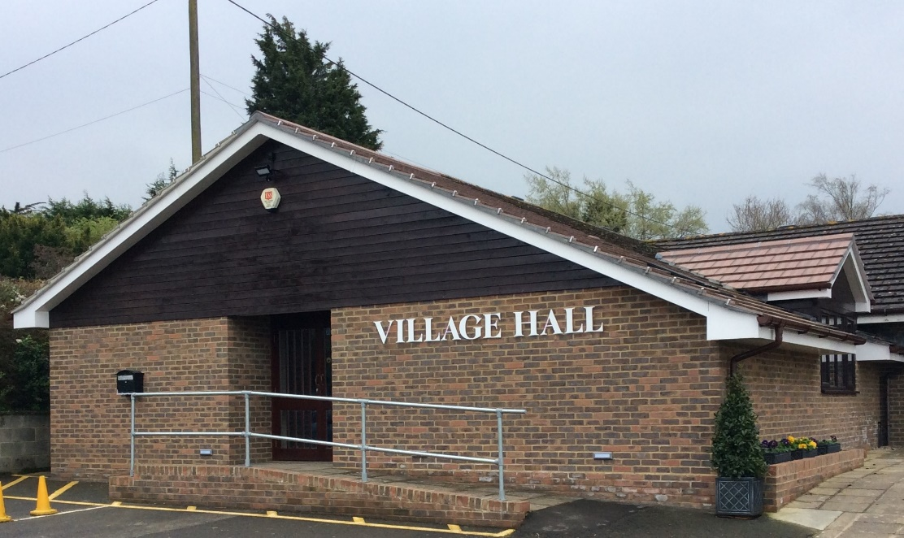

Website: bodlestreetvillagehall.org

Bodle Street Green Village Hall
The Causeway,
Bodle Street Green
Herstmonceux, East Sussex BN27 4UB

Independent Examiner: Mr. Joel Andrews, Sunnyside, Victoria Road, Herstmonceux, East Sussex BN27 4TA

Bankers: CAF Bank Ltd, 25 Kings Hill Avenue, Kings Hill, West Malling, Kent, ME19 4JQ
BODLE STREET GREEN VILLAGE HALL TRUST

TRUSTEES ANNUAL REPORT for 2019

Background History: The Bodle Street Green Village Hall Trust was established by Trust Deed on 19th December 1923 and registered as a charity under number 227875 on 30th January 1964.

Our aims and purposes as a charity:

The Hall Management Committee has the responsibility for fulfilling the main objects of the Trust, as laid out in the Trust Deed, which are to hold the Village Hall and any associated buildings and land for the enjoyment, use and occupation of the inhabitants of the Ecclesiastical Parish of Bodle Street Green irrespective of creed or religious sect for all purposes of instruction, amusement, recreation and social life.

What we planned to do to achieve our charitable objectives:

When planning our activities for the year, the Hall Management Committee have considered the Charity Commission’s guidance on public benefit. In particular, we try to enable residents in the parish and surrounding areas to live out their lives to the full through:

- Providing facilities and activities for people with disabilities.
- Providing community facilities, including broadband, for Parish Council, Parochial Church Council, a wide range of local societies and individuals.
- Encouraging physical well-being with classes for pilates, short mat bowls, folk dancing and Irish dancing.
- Enhancing local cohesion through the provision of films, stage shows and other entertainment
- Providing reception and catering facilities for a wide range of local users.

What we have achieved and how we affected beneficiaries’ lives:

2019 showed an increase in village activities and events using the hall with a high record level of usage particularly in the evenings.

The Bodle Street Women’s Institute held their monthly events in the Hall together with a number of lunches and teas for visiting charitable organisations. The Bodle Street Green Gardening Club held five of their monthly lectures in the Hall together with a Plant Sale & Quiz in May and the Annual Flower Show in August. The Villages Luncheon Club met on the 3rd Monday of each month. The Short Mat Bowls and The Herstmonceux Folk Dancers meet Monday and Wednesday evening respectively.

A local Pilates Group meets on Wednesday, Thursday and Friday mornings. The East Sussex Association for the Blind – Tuesday Club usually holds some of its meetings in the evening of the 2nd Tuesday of the month. Private hirings for wedding receptions, parties and one-off events organised by local societies continued at an increased level. The Film Club met on the last Friday evening of each month.

Warbleton Parish Council held 5 of its regular monthly meetings (May, June, July, September & November) in the Hall and between July and December also held its fortnightly planning meeting on a Tuesday morning using the broadband connection and large screen TV. The Hall was also used as a Polling Station whenever necessary for Parish, District, County and National elections.

During the year, the following events were organised by the Village Hall Committee:

1st January Bring & Share Luncheon with St. John’s Church
30th March Spanish Evening with ‘Carmen’
3rd May Annual General Meeting with refreshments
28th September Murder Mystery Evening
6th December Pantomime – Dick Whittington - evening performance
7th December Pantomime – Dick Whittington – matinee and evening performances

Local residents also organized a very successful ‘ABBA Tribute Evening’ which made a significant contribution to Hall funds. The Hall was also used to host a charity event on the 21st September in aid of ‘The Starfish’ project and a further charity fundraising event was held on 26th October 2019.

Bodle Street (St. John’s) Parochial Church Council (PCC) used the hall for their Annual Meeting which was followed by Supper and also on a number of occasions for social events following Church Services such as Harvest Festival and the Carol Service. The PCC also used the Hall for the Annual Summer Fayre on 22nd June 2019.

The Committee particularly appreciates the efforts of committee members and others who volunteer to help in the smooth operation of the Hall, who regularly maintain the flower beds on the Terrace and between the Hall and White Horse Inn car parks and who assist in the organisation of events. The committee continues to appreciate the support of the Parish Council towards the maintenance of the Green. The Village Hall web-site, which can be seen at www.bodlestreetvillagehall.org is used to publicise events, provide a forum for local societies and essential information including copies of Annual Reports.

Financial Review:

The full accounts are detailed on pages 5 - 9 of this report. Income from Hiring Charges showed a significant increase to £10,574.00 (£8,104.00 in 2018). General donations totaled £689.00 (£770.00 in 2018) together with the annual grant of £300.00 from Warbleton Parish Council towards the maintenance of Green which is owned by the Hall. Events held during the year brought in £6,377.00 and the income from the Film Club was £2,170.00. Interest on Bank funds totaled £16.00.

Costs associated with the day-to-day running of the Hall and Green totaled £8,423.00 (£7,903.00 in 2018). Maintenance charges were £1,055.00 with new hand dryers in the Ladies & Gents toilets and electrical charges associated with installing a new hob in the kitchen and the hand dryers. The insurance premium for the year was £976.00 (£1,018.00 in 2018) with £147.00 spent on professional charges. Repayments on the loan arranged from ACRE in 2016 totaled £4,554. Expenditure on events organized by the Hall Committee amounted to £2,282.00 (£1,352.00 in 2018). There was also additional capital expenditure of £408.00 on a replacement hob in the kitchen.

Total income was £19,826.00 against expenditure of £17,952.00, giving an excess of income over expenditure of £1,874.00

Reserves Policy:

It is Committee’s policy to try and maintain a balance of unrestricted funds which equates to at least three months’ unrestricted payments. This is equivalent to £3,000.00 which is held to smooth out fluctuations in cash flow. To meet the repayment terms under the loan agreement with ACRE, the committee will seek to maintain a further balance of £4,000.00 in unrestricted funds.

Trustees:

The Freehold ‘Holding’ Trustees are Mr. B D Cooper, Mr. B D Gibson MBE & Mrs. Philippa Gentry. Under the terms of the Trust Deed, a Committee, appointed annually, manages the Village Hall and committee members who have served at any time from 3rd May 2019 until the date this report was approved were: Mr. Charles Harding (Chairman), Mr. Geoff Holt (Secretary), Mr. Bryan Gibson MBE (Treasurer), Mr. Barrie Cooper, Mrs. Judith Cooper, Mrs. Philippa Gentry, Mrs. Flowie Georgiou, Mrs. Mary Gibson, Mrs. Margaret Holt, Mrs. Shirley Price MBE, Mrs. Sue Ralph, Mrs. Judy Swan Mrs. Caroline Thompson & Mrs. Pauline Velten. Mrs. Ros Billinghurst (Bookings Clerk) also attends committee meetings as an observer.

Bankers: The Bankers of the Trust are CAF Bank Ltd, 25 Kings Hill Avenue, Kings Hill, West Malling, Kent, ME19 4JQ.

Location: The address of the Hall is Bodle Street Green Village Hall, The Causeway, Bodle Street Green, Herstmonceux, BN27 4UB. The address for correspondence is Mr. Bryan Gibson MBE, Treasurer, Millers Cottage, Herstmonceux, BN27 4RS.

The Trustees Annual Report was approved by the Hall Management Committee and signed on their behalf by Mr. Charles Harding, Committee Chairman.

________________________________________________________ Date: April 2020

Annual Financial Report

of

BODLE STREET GREEN
VILLAGE HALL TRUST FUND
Charity Registration Number: 227875

For the year ended 31st DECEMBER 2019

CONTENTS

Page

Summary of financial receipts and payments 6

Statement of assets and liabilities (receipts & payments) 7

Notes to the Accounts 8 - 9

Report of the Independent Examiner 10

BODLE STREET GREEN VILLAGE HALL TRUST FUND
(Registered Charity No: 227875)

Summary of Financial Receipts & Payments

The financial effect of our activities during the year can be summarised as follows:

Unrestricted Funds Total 2019 Total 2018
Income from: £ £ £
Donations 389 389 470
Charitable activities 19,121 19,121 15,638
Inland Revenue Refund 0 0 0
Grounds 300 300 300
Interest 16 16 7

Total Received £19,826 £19,826 £16,415 Note 2

Expenditure on:
Cost of raising funds 11,788 11,788 10,273
Charitable costs 1,202 1,202 1,129
Capital expenditure 408 408 183
Loan Repayments 4,554 4,554 4,554

Total paid £17,952 £17,952 £16,139 Note 3

Reconciliation of funds:

Net Income
or (net) expenditure 1,874 1,874 276

Bank accounts at 1 January 10,139 10,139 9,863

Bank accounts at 31 December £12,013 £12,013 £10,139

BODLE STREET GREEN VILLAGE HALL TRUST FUND
(Registered Charity No: 227875)

Statement of Assets and Liabilities (Receipts and Payments presentation)

 | General Fund 2019 | General Fund 2018 | Notes
 | £ | £
Assets
Bank current account | 155 | 740
Bank deposit account | 11,764 | 9,384
Petty Cash | 93 | 15
Bank & Deposit Accounts | £12,012 | £10,139
Debtors | 0 | 0
Land & Buildings |  |  | 4
Hall at 31/12/18 | 171,796 | 174,730
Add Extension Build | 0 | 0
Less Depreciation | 2,934 | 2,934
Value at 31/12/19 | £168,862 | £171,796
Fixtures & Fittings
Value at 31/12/18 | 4,481 | 8,072 | 4
Add 2018 expend | 408 | 183
Less Depreciation | 3,876 | 3,774
Value at 31/12/19 | £1,013 | 4,481
Total Assets | £181,887 | £186,416
Liabilities
ACRE Loan - outstanding | 7,199 | 11,753 | 6
Total Liabilities | 7,199 | 11,753
Net Assets – 31/12/19 | £174,663 | £174,663

This Financial Report for the year ended 31st December 2019, including the notes following, was approved by the Village Hall Management Committee and signed on its behalf by Mr. Bryan D Gibson MBE, Treasurer.

B D Gibson
___________________________________________

Date _____ April 2020

BODLE STREET GREEN VILLAGE HALL TRUST FUND
(Registered Charity No: 227875)

Notes to the Financial Report

- The financial statements of the Trust have been prepared in accordance with the Charities Act 2011 using the Receipts and Payments basis.

- Analysis of total received

 | General Fund 2019 | All Funds 2018 | Notes
 | £ | £
Hiring Charges | 10,574 | 8,104
Donations – General | 689 | 770
Gift Aid recoverable | 0 | 0
Events | 6,377 | 5,928
Interest | 16 | 7
Film Club | 2,170 | 1,606
Total Received | 19,826 | 16,415
3 Analysis of total paid

 | General Fund 2019 | All funds 2018 | Notes
 | £ | £
Direct Charitable Expenditure
Hall Costs | 8,423 | 7,903
Insurance | 976 | 1,018 | 5
Events | 2,282 | 1,352
Charitable Donations | 0 | 0
Fixtures & Fittings | 408 | 183
Film Club | 107 | 0
Total Charitable Expenditure | £12,196 | £10,456
Management & Administration
Legal & Professional | 147 | 278
Loan Repayment | 4,554 | 4,554 | 6
Hall & Grounds Maintenance | 1,055 | 851
Total | £5,756 | £5,683

4. TANGIBLE FIXED ASSETS

Land & Buildings:
In the original Trust Deed dated 19th December 1923 paragraph 4 states: “If and when the Village Hall is no longer required or used for the benefit of the inhabitants aforesaid or for the purposes hereinbefore specified or some of them this present grant shall at the expiration of Two years from the cessor of such user thereupon become annulled and of no effect and the said land shall revert to and become the property in fee simple of the Donor or other the person or persons who may then be the absolute or reversionary absolute owner of the said field numbered 36 thereinbefore mentioned PROVIDED ALWAYS that on the happening of such an event the Trustees their heirs successors and assigns shall have the right within reasonable time after the expiration of such two years to sell and remove or take away the said Village Hall and Buildings from the said land doing no more damage than is necessary in the act of such removal.”

The land on which the Hall and Green are situated is, therefore, held in trust and is not valued. In the opinion of the Trustees, given the restrictions imposed by the Trust Deed, it is unrealistic to value the Hall at market value. Therefore, the buildings are shown in the balance sheet at cost less depreciation. Under the terms of the National Lottery grant awarded in 1998 to build the new Hall, the hall must be depreciated over 80 years. The new Hall, built in 1998, cost £150,170.00 to build which over 80 years gives an annual depreciation of £1,877.00. The residual value of the Hall at the end of 2015 was £116,126.00. Building the extension in 2016 cost £64,472.00 which will now be depreciated over 61 years (The balance of the 80 years since 1998). This increases the annual depreciation by £1,057.00 giving a total annual depreciation for the building of £2,934.00.

Fixture & Fittings: Depreciation is provided on all tangible fixed assets at rates calculated to write off the cost of each asset evenly over its expected useful life, which for Fixtures and fittings is 4 years. At the end of 2015, all fixtures and fittings had been depreciated to zero. Since 2016, various additional expenditure gave a total annual depreciation of £3,774.00 for 2018. Further expenditure in 2019 of £408 depreciated over 4 years increased the depreciation for 2019 to £3,876.

- INSURANCE

The Hall and its contents are insured with Allied Westminster (Insurance Services) Ltd under a ‘VillageGuard Village Hall’ Insurance Policy. Following on from the completion of the extension in 2016, the Hall was re-valued for insurance purposes and is currently insured for £597,525.00. For insurance purposes, the contents of the Hall are insured for £27,518.00.

- ACRE LOAN

A successful application for a loan was made to ‘Action with Communities in Rural Areas’ (ACRE) and agreed on 22nd April 2016 and a cheque for £22,000.00 was received on 24th June 2016. This is to be repaid over 5 years (20 Quarterly payments) with an interest rate of 1.32%. The first repayment installment was paid on 15th October 2016.

- TRUSTEES REMUNERATION AND EXPENSES

The Trustees received neither remuneration nor expenses from the charity. Some payments were made to Trustees during the year for reimbursement of expenses incurred on behalf of the Trust.

BODLE STREET GREEN VILLAGE HALL TRUST FUND

INDEPENDENT EXAMINER’S REPORT ON THE ACCOUNTS

Independent Examiner’s Report to the Trustees and Management Committee of the Bodle Street Green Village Hall Trust (Charity Registration Number: 227875) for the year ended 31st December 2019.

This is my report to the Management Committee of the Bodle Street Green Village Hall Trust, on the annual report for the year ended 31st December 2019 set out on pages 9 and 10.

Respective responsibilities of Trustees and Examiner
The committee members are responsible for the preparation of the annual reports. The Management Committee consider that an audit is not required for this year under section 144 of the Charities Act 2011 (“The Charities Act”) and that an independent examination is needed.
It is my responsibility to
- Examine the accounts under section 145 of the 2011 Act;
- Follow the procedures laid down in the General Directions of the Charity Commissioners section 145(5)(b) of the Charities Act; and
- State whether particular matters have come to my attention.

Basis of Independent Examiner’s Statement

My examination was carried out in accordance with the General Directions given by the Charity Commission. An examination includes a review of the accounting records kept by the charity and a comparison of the accounts with those records. It also includes considering any unusual items or disclosures in the accounts and seeking explanations from the trustees concerning any such matters. The procedures undertaken do not provide all the evidence that would be required in a full audit, and consequently no opinion is given as to whether the accounts present a ‘true and fair’ view and the report is limited to those matters set out in the statement below.

Independent Examiner's Statement

In connection with my examination, no material matters have come to my attention which gives me cause to believe that in, any material respect:
- accounting records were not kept in accordance with section 130 of the Charities Act or
- the accounts do not accord with the accounting records
I have come across no other matters in connection with the examination to which attention should be drawn in order to enable a proper understanding of the accounts to be reached.

Examiner’s signature ………………………………………………………………………………………………………

Examiner’s name capitals Mr. JOEL ANDREWS

Date ……………………....... Relevant professional qualification(s) or body (if any) ……………………………….

Examiner’s Address: Sunnyside, Victoria Road, Herstmonceux, East Sussex BN27 4TA

