TRUSTEES ANNUAL REPORT AND FINANCIAL REPORT

of

BODLE STREET GREEN
VILLAGE HALL TRUST FUND
Charity Registration Number: 227875

For the year ended 31st DECEMBER 2022

CONTENTS

Page
Trustees Annual Report 2 - 3

Summary of financial receipts and payments 5

Statement of assets and liabilities (receipts & payments) 6

Notes to the Accounts 7 - 8

Report of the Independent Examiner 9
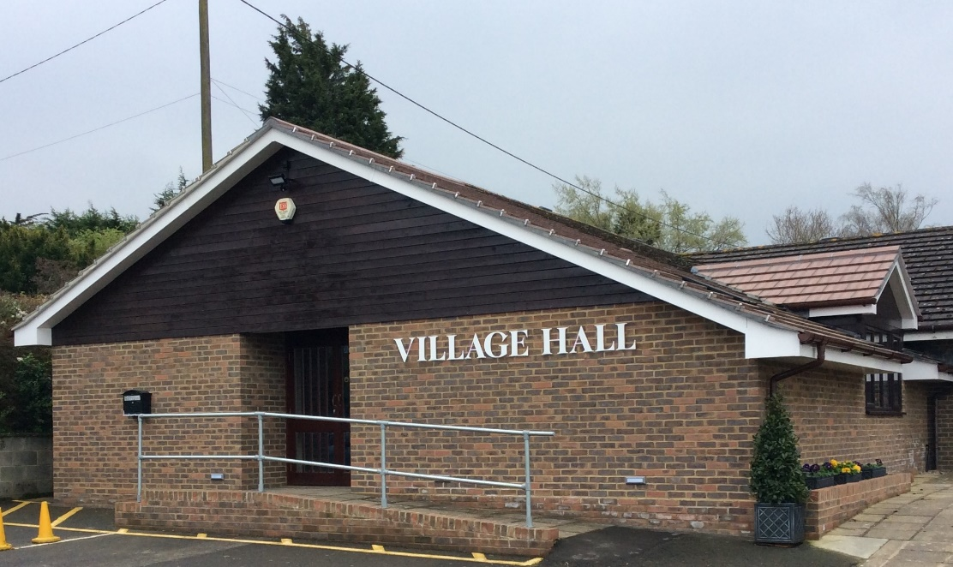

Website: bodlestreetvillagehall.org

Bodle Street Green Village Hall
The Causeway,
Bodle Street Green
Herstmonceux, East Sussex BN27 4UB

Independent Examiner: Mr. Philip Hale, The Old Stores, Bodle Street Green, BN27 4RA

Bankers: CAF Bank Ltd, 25 Kings Hill Avenue, Kings Hill, West Malling, Kent, ME19 4JQ
BODLE STREET GREEN VILLAGE HALL TRUST

TRUSTEES ANNUAL REPORT for 2022

Background History: The Bodle Street Green Village Hall Trust was established by Trust Deed on 19th December 1923 and registered as a charity under number 227875 on 30th January 1964.

Our aims and purposes as a charity:

The Hall Management Committee has the responsibility for fulfilling the main objects of the Trust, as laid out in the Trust Deed, which are to hold the Village Hall and any associated buildings and land for the enjoyment, use and occupation of the inhabitants of the Ecclesiastical Parish of Bodle Street Green irrespective of creed or religious sect for all purposes of instruction, amusement, recreation and social life.

What we planned to do to achieve our charitable objectives:

When planning our activities for the year, the Hall Management Committee have considered the Charity Commission’s guidance on public benefit. In particular, we try to enable residents in the parish and surrounding areas to live out their lives to the full through:

- Providing facilities and activities for people with disabilities.
- Providing community facilities, including broadband, for Parish Council, Parochial Church Council, and a wide range of local societies and individuals.
- Encouraging physical well-being with classes for Pilates, Yoga, short mat bowls, folk dancing and Irish dancing.
- Enhancing local cohesion through the provision of films, stage shows and other entertainment
- Providing reception and catering facilities for a wide range of local users.

What we have achieved and how we affected beneficiaries’ lives:

During 2022, the usage of the Hall showed a welcome return to pre-pandemic levels. Local societies and groups, once again, held regular meetings and communal events were well supported.

‘The Tuesday Group’ normally meet on the second Tuesday of each Month. The Bodle Street Green Gardening Club had a full programme of events including the Annual Flower Show in August. The Villages Lunches Club on the third Monday of each month throughout the year. The Herstmonceux Folk Dancers met every Wednesday evening and Short Mat Bowls met on Wednesday afternoons.

Two separate Pilates Groups held regular sessions on Wednesday and Thursday mornings and a Yoga session was held on Tuesday mornings. A Dog Training Group started meeting regularly at the Hall using the Green whenever possible. The Irish dance class was held regularly on Thursday evenings and a ‘Rugby Tots’ started in November meeting on Saturday mornings. There were regular private hirings for wedding receptions, funeral wakes, birthday parties and other one-off events. Unfortunately, the Film Club decided to discontinue their monthly meetings.

Warbleton Parish Council used the Hall to hold Council and planning meetings using the Hall facilities. Bodle Street PCC held its APCM in May and also organised a very successful Village Fayre in July. A lunch was held in the Hall after the Harvest Festival Church Service in September and refreshments after the Carol Service on 24th December. The Village also celebrated H.M. The Queen’s Platinum Jubilee with a well-attended Bring & Share Lunch in June.

During the year, the Village Hall Committee organized a Jumble Sale and Big Band Concert both in October and a Barn Dance in November. There was also a very successful Christmas Market and the Hall also hosted a Christmas Fair.

Financial Review:

The full accounts are detailed on pages 5 - 8 of this report. Income from Hiring Charges have begun to return to pre-pandemic levels at £9,602.00 (£5,517 in 2021). Donations totaled £360.00 (£150.00 in 2010) together with a grants of £1,150.00 from Warbleton Parish Council which include £150.00 to support The Queen’s Platinum Jubilee event. Interest on Bank funds totaled £38.00. In 2021. the Hall also received a grant of £2,920.00 from the Wealden District Council Recovery Fund 2021 to replace fencing on the North and West sides of the Green with the work being carried out in 2022. Events held in the year produced a net income of £2,629.00 (£1,048.00 in 20210

Costs associated with the day-to-day running of the Hall and Green reflect the increased usage and totaled £9,810.00 ( £ 5,704.00 in 2020). During 2022, the water boiler and satellite dish needed to be replaced at a cost of £1,128.00. Maintenance charges were £5,372.00 which included the replacement of the fence around the Green for which a grant of £2,920.00 was received in 2021. Other costs being repairs to the hot cupboard, replacement gazebo, installation of the new water heater, a new electrical test certificate and associated electrical repairs. The insurance premium for the year was £1,097.00 (£1,007.00 in 2021) with £86.00 spent on professional charges.

Total income was £15,549.00 against expenditure of £18,937.00, giving an excess expenditure over income of £3,388.00. Excluding the cost of the replacement fence around the Green which was shown as a liability in the 2021 accounts the true deficit in 2022 was £468.00.

Reserves Policy:

It is Committee’s policy to try and maintain a balance of unrestricted funds which equates to at least six months’ unrestricted payments at pre pandemic levels. This is equivalent to £7,000.00 which is held to smooth out fluctuations in cash flow. The Committee also believes it is prudent to have a further £5,000.00 in reserves to meet future maintenance requirements as the Hall is now 25 years old.

Trustees:

The Freehold ‘Holding’ Trustees are Mr. B D Cooper, Mr. B D Gibson MBE, Mrs. Philippa Gentry and Mrs. Margaret Holt. Under the terms of the Trust Deed, a Committee is appointed annually to manage the Village Hall and committee members who have served at any time during the period covered by this report were: Mr. Charles Harding (Chairman), Mr. Geoff Holt (Secretary), Mr. Bryan Gibson MBE (Treasurer), Mr. Joel Andrews, Ms. Julie Brown, Mrs. Philippa Gentry, Mrs. Flowie Georgiou, Mrs. Lindsay Godwin, Ms Nicki Harris, Mrs. Margaret Holt, Mrs. Kim Lineham, Mr. Peter Love, Mrs. Sue Ralph, Mr. Andrew Stredder, Mrs. Pauline Velten & Mrs. Mary Williamson. Mrs. Ros Billinghurst (Bookings Clerk) also attends committee meetings as an observer.

Bankers: The Bankers of the Trust are CAF Bank Ltd, 25 Kings Hill Avenue, Kings Hill, West Malling, Kent, ME19 4JQ.

Location: The address of the Hall is Bodle Street Green Village Hall, The Causeway, Bodle Street Green, Herstmonceux, BN27 4UB. The address for correspondence is Mr. Bryan Gibson MBE, Treasurer, “Formiles”, 1 Nursery Lane, Herstmonceux, BN27 4TP.

The Trustees Annual Report was approved by the Hall Management Committee and signed on their behalf by Mr. Charles Harding, Committee Chairman.

________________________________________________________ Date: 11th April 2023

Annual Financial Report

of

BODLE STREET GREEN
VILLAGE HALL TRUST FUND
Charity Registration Number: 227875

For the year ended 31st DECEMBER 2022

CONTENTS

Page

Summary of financial receipts and payments 5

Statement of assets and liabilities (receipts & payments) 6

Notes to the Accounts 7 - 8

Report of the Independent Examiner 9

BODLE STREET GREEN VILLAGE HALL TRUST FUND
(Registered Charity No: 227875)

Summary of Financial Receipts & Payments

The financial effect of our activities during the year can be summarised as follows:

Unrestricted Funds Total 2022 Total 2021
Income from: £ £ £
Donations 360 360 120
Charitable activities 14,001 14,001 6,998
Grounds 0 0 0
Interest 38 38 1
Grants 1,150 1,150 3,220

Total Received £15,549 £15,549 £10,369 Note 2

Expenditure on:
Cost of raising funds 12,351 12,351 7,144
Charitable costs 5,458 5,458 1,019 Note 7
Capital expenditure 1,128 1,128 0
Loan Repayments 0 0 3,416

Total paid £18,937 £18,937 £11,579 Note 3

Reconciliation of funds:

Net Income
or (net) expenditure (3,388) (3,388) (1,210) Note 7

Bank accounts at 1 January £13,604 £13,604 14,814

Bank accounts at 31 December £10,216 £10,216 £13,604

BODLE STREET GREEN VILLAGE HALL TRUST FUND
(Registered Charity No: 227875)

Statement of Assets and Liabilities (Receipts and Payments presentation)

 | General Fund 2022 | General Fund 2021 | Notes
 | £ | £
Assets
Bank current account | 1,280 | 4,024
Bank deposit account | 8,839 | 9,580
Petty Cash | 97 | 0
Bank & Deposit Accounts | £10,216 | £13,604
Debtors | 0 | 0
Land & Buildings |  |  | 4
Hall at 31/12/21 | 162,994 | 165,928
Add Extension Build | 0 | 0
Less Depreciation | 2,934 | 2,934
Value at 31/12/22 | £160,060 | £162,994
Fixtures & Fittings
Value at 31/12/21 | 0 | 0 | 4
Add 2022, expend | 1,128 | 0
Less Depreciation | 282 | 0
Value at 31/12/22 | 846 | 0
Total Assets | £171,122 | £176,598
Liabilities
Cost of Fencing round Green | 0 | 2,920 | 7
Total Liabilities | 0 | 2,920
Net Assets – 31/12/22 | £171,122 | £173,678

This Financial Report for the year ended 31st December 2022, including the notes following, was approved by the Village Hall Management Committee and signed on its behalf by Mr. Bryan D Gibson MBE, Treasurer.

___________________________________________

Date: 11th April 2023

BODLE STREET GREEN VILLAGE HALL TRUST FUND
(Registered Charity No: 227875)

Notes to the Financial Report

- The financial statements of the Trust have been prepared in accordance with the Charities Act 2011 using the Receipts and Payments basis.

- Analysis of total received

 | General Fund 2022 | General Fund 2021 | Notes
 | £ | £
Hiring Charges | 9,602 | 5,517
Donations – General | 360 | 150
Gift Aid recoverable | 0 | 0
Events | 4,073 | 1,481
Interest | 38 | 1
Film Club | 326 | 0
Grants | 1,150 | 3,220
Total Received | £15,549 | £10,369
3 Analysis of total paid

 | General Fund 2022 | General Fund 2021 | Notes
 | £ | £
Direct Charitable Expenditure
Hall Costs | 9,810 | 5,704
Insurance | 1,097 | 1,007 | 5
Events | 1,444 | 433
Charitable Donations | 0 | 0
Fixtures & Fittings | 1,128 | 0
Film Club | 0 | 0
Total Charitable Expenditure | £13,479 | £7,144
Management & Administration
Legal & Professional | 86 | 101
Loan Repayment | 0 | 3,416 | 6
Hall & Grounds Maintenance | 5,372 | 918 | 7
Total | £5,458 | £4,435

4. TANGIBLE FIXED ASSETS

Land & Buildings:
In the original Trust Deed dated 19th December 1923 paragraph 4 states: “If and when the Village Hall is no longer required or used for the benefit of the inhabitants aforesaid or for the purposes hereinbefore specified or some of them this present grant shall at the expiration of Two years from the cessor of such user thereupon become annulled and of no effect and the said land shall revert to and become the property in fee simple of the Donor or other the person or persons who may then be the absolute or reversionary absolute owner of the said field numbered 36 thereinbefore mentioned PROVIDED ALWAYS that on the happening of such an event the Trustees their heirs successors and assigns shall have the right within reasonable time after the expiration of such two years to sell and remove or take away the said Village Hall and Buildings from the said land doing no more damage than is necessary in the act of such removal.”

The land on which the Hall and Green are situated is, therefore, held in trust and is not valued. In the opinion of the Trustees, given the restrictions imposed by the Trust Deed, it is unrealistic to value the Hall at market value. Therefore, the buildings are shown in the balance sheet at cost less depreciation. Under the terms of the National Lottery grant awarded in 1998 to build the new Hall, the hall must be depreciated over 80 years. The new Hall, built in 1998, cost £150,170.00 to build which over 80 years gives an annual depreciation of £1,877.00. The residual value of the Hall at the end of 2015 was £116,126.00. Building the extension in 2016 cost £64,472.00 which will now be depreciated over 61 years (The balance of the 80 years since 1998). This increases the annual depreciation by £1,057.00 giving a total annual depreciation for the building of £2,934.00.

Fixture & Fittings: Depreciation is provided on all tangible fixed assets at rates calculated to write off the cost of each asset evenly During 2022, replacement Water Boiler and Satellite Dish cost £1,128.00 giving an annual depreciation of £282.00.

- INSURANCE

The Hall and its contents are insured with Allied Westminster (Insurance Services) Ltd under a ‘VillageGuard Village Hall’ Insurance Policy. The Hall was re-valued for insurance purposes in September 2021 and is now insured for £780,369.00 plus a further cover of £2,000.00 for The Green. For insurance purposes, the contents of the Hall are insured for £28,659.00.

- ACRE LOAN

A successful application for a loan was made to ‘Action with Communities in Rural Areas’ (ACRE) and agreed on 22nd April 2016 and a cheque for £22,000.00 was received on 24th June 2016. This is to be repaid over 5 years (20 Quarterly payments) with an interest rate of 1.32%. The first repayment installment was paid on 15th October 2016 and the final payment was made in July 2021.

- New Fencing around the Green totaling £2,820.00 was paid for by a Grant from Wealden District Council received in 2021.

- TRUSTEES REMUNERATION AND EXPENSES

The Trustees received neither remuneration nor expenses from the charity. Some payments were made to Trustees during the year for reimbursement of expenses incurred on behalf of the Trust.

BODLE STREET GREEN VILLAGE HALL TRUST FUND

INDEPENDENT EXAMINER’S REPORT ON THE ACCOUNTS

Independent Examiner’s Report to the Trustees and Management Committee of the Bodle Street Green Village Hall Trust (Charity Registration Number: 227875) for the year ended 31st December 2022.

This is my report to the Management Committee of the Bodle Street Green Village Hall Trust, on the annual report for the year ended 31st December 2022 set out on pages 9 and 10.

Respective responsibilities of Trustees and Examiner
The committee members are responsible for the preparation of the annual reports. The Management Committee consider that an audit is not required for this year under section 144 of the Charities Act 2011 (“The Charities Act”) and that an independent examination is needed.
It is my responsibility to
- Examine the accounts under section 145 of the 2011 Act;
- Follow the procedures laid down in the General Directions of the Charity Commissioners section 145(5)(b) of the Charities Act; and
- State whether particular matters have come to my attention.

Basis of Independent Examiner’s Statement

My examination was carried out in accordance with the General Directions given by the Charity Commission. An examination includes a review of the accounting records kept by the charity and a comparison of the accounts with those records. It also includes considering any unusual items or disclosures in the accounts and seeking explanations from the trustees concerning any such matters. The procedures undertaken do not provide all the evidence that would be required in a full audit, and consequently no opinion is given as to whether the accounts present a ‘true and fair’ view and the report is limited to those matters set out in the statement below.

Independent Examiner's Statement

In connection with my examination, no material matters have come to my attention which gives me cause to believe that in, any material respect:
- accounting records were not kept in accordance with section 130 of the Charities Act or
- the accounts do not accord with the accounting records
I have come across no other matters in connection with the examination to which attention should be drawn in order to enable a proper understanding of the accounts to be reached.

Examiner’s signature ………………………………………………………………………………………………………

Examiner’s name capitals Mr. PHILIP HALE

Date: . Relevant professional qualification(s) or body (if any) ……………………………….

Examiner’s Address: The Old Stores, Windmill Hill Road, Bodle Street Green, BN27 4RA

