TRUSTEES ANNUAL REPORT AND FINANCIAL REPORT

of

BODLE STREET GREEN
VILLAGE HALL TRUST FUND
Charity Registration Number: 227875

For the year ended 31st DECEMBER 2021

CONTENTS

Page
Trustees Annual Report 2 - 3

Summary of financial receipts and payments 5

Statement of assets and liabilities (receipts & payments) 6

Notes to the Accounts 7 - 8

Report of the Independent Examiner 9
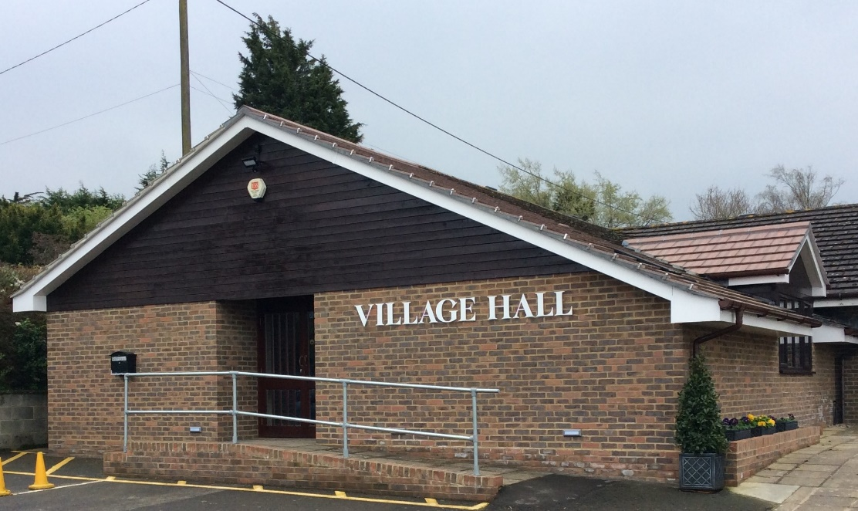

Website: bodlestreetvillagehall.org

Bodle Street Green Village Hall
The Causeway,
Bodle Street Green
Herstmonceux, East Sussex BN27 4UB

Independent Examiner: Mr. Joel Andrews, Sunnyside, Victoria Road, Herstmonceux, East Sussex BN27 4TA

Bankers: CAF Bank Ltd, 25 Kings Hill Avenue, Kings Hill, West Malling, Kent, ME19 4JQ
BODLE STREET GREEN VILLAGE HALL TRUST

TRUSTEES ANNUAL REPORT for 2021

Background History: The Bodle Street Green Village Hall Trust was established by Trust Deed on 19th December 1923 and registered as a charity under number 227875 on 30th January 1964.

Our aims and purposes as a charity:

The Hall Management Committee has the responsibility for fulfilling the main objects of the Trust, as laid out in the Trust Deed, which are to hold the Village Hall and any associated buildings and land for the enjoyment, use and occupation of the inhabitants of the Ecclesiastical Parish of Bodle Street Green irrespective of creed or religious sect for all purposes of instruction, amusement, recreation and social life.

What we planned to do to achieve our charitable objectives:

When planning our activities for the year, the Hall Management Committee have considered the Charity Commission’s guidance on public benefit. In particular, we try to enable residents in the parish and surrounding areas to live out their lives to the full through:

- Providing facilities and activities for people with disabilities.
- Providing community facilities, including broadband, for Parish Council, Parochial Church Council, a wide range of local societies and individuals.
- Encouraging physical well-being with classes for Pilates, short mat bowls, folk dancing and Irish dancing.
- Enhancing local cohesion through the provision of films, stage shows and other entertainment
- Providing reception and catering facilities for a wide range of local users.

What we have achieved and how we affected beneficiaries’ lives:

The usage of the Hall during 2021 was, once again, seriously affected by the various periods of lockdown ordered by the UK Government. When allowed by the regulations, the Hall continued to provide a range of services for the Village and local community.

‘The Tuesday Group’ who normally meet on the second Tuesday of each Month managed to restart in August and then held 2 further meetings plus a luncheon for cyclists. The Bodle Street Green Gardening Club held its first meeting of the year in June followed by the Annual Flower Show in July and then three further meetings in the later part of the year. The Villages Lunches Club restarted in July and then held meetings on the third Monday of each month for the rest of the year. The Short Mat Bowls and The Herstmonceux Folk Dancers were also able to hold regular meetings from September.

Two separate Pilates Groups held regular sessions on Wednesday and Thursday mornings from September. Jiu Jitsu were also held during the year whenever regulations allowed. A Dog Training Group started meeting regularly at the Hall using the Green whenever possible There were very few private hirings for wedding receptions, parties and one-off events organised by local societies due to Government restrictions. The Film Club was able to meet on the last Friday evening of each month for part of the year.

Warbleton Parish Council was able to return to holding Council and planning meetings using the Hall facilities. Bodle Street PCC held its APCM in May and also organised a very successful Village Fayre in July. A lunch was held in the Hall after the Harvest Festival Church Service in September. A joint meeting of Parish Treasurers from the Uckfield and Dallington Deanerys was held in October both in person and by Zoom.

During the year, the Village Hall Committee was only able to organized a Jumble Sale in October and hosted a Christmas Market in November.

Financial Review:

The full accounts are detailed on pages 5 - 8 of this report. Due to the restrictions on the use of the Hall, income from Hiring Charges remains below the historic average but was broadly similar to the income in 2020 at £5,517.00 (£5,878.00 in 2020). General donations totaled £1500.00 (£120.00 in 2020) together with a grant of £300.00 from Warbleton Parish Council. Interest on Bank funds totaled £1.00. The Hall also received a grant of £2,920.00 from the Wealden District Council Recovery Fund 2021 to replace fencing on the North and West sides of the Green. The limited number of events held in the year produced a net income of £1,048.00

Many of the costs associated with the day-to-day running of the Hall and Green continued despite limitations on its use and totaled £5,704.00 ( £ 7,449.00 in 2020). Maintenance charges were £918.00; costs being repairs to the sheds, the lawn mower and gazebos. The insurance premium for the year was £1,007.00 (£986.00 in 2020) with £101.00 spent on professional charges. Final repayments on the loan arranged from ACRE in 2016 totaled ££3,416.00.

Total income was £10,369.00 against expenditure of £11,579.00, giving an excess expenditure over income of £1,210.00

Reserves Policy:

It is Committee’s policy to try and maintain a balance of unrestricted funds which equates to at least six months’ unrestricted payments at pre pandemic levels. This is equivalent to £6,000.00 which is held to smooth out fluctuations in cash flow. The Committee also believes it is prudent to have a further £5,000.00 in reserves to meet future maintenance requirements as the Hall is now 25 years old.

Trustees:

The Freehold ‘Holding’ Trustees are Mr. B D Cooper, Mr. B D Gibson MBE & Mrs. Philippa Gentry with Mrs. Margaret Holt being appointed an additional ‘Holding Trustee in September 2021. Under the terms of the Trust Deed, a Committee is appointed annually to manage the Village Hall and committee members who have served at any time during the period covered by this report were: Mr. Charles Harding (Chairman), Mr. Geoff Holt (Secretary), Mr. Bryan Gibson MBE (Treasurer), Mr. Barrie Cooper (resigned 30 June 2021), Mrs. Judith Cooper (resigned 30 June 2021), Mrs. Philippa Gentry, Mrs. Flowie Georgiou, Mrs. Margaret Holt, Mrs. Shirley Price MBE, Mrs. Sue Ralph, Mrs. Judy Swan (resigned 30 June 2021) Mrs. Caroline Thompson & Mrs. Pauline Velten. Mrs. Ros Billinghurst (Bookings Clerk) also attends committee meetings as an observer.

Bankers: The Bankers of the Trust are CAF Bank Ltd, 25 Kings Hill Avenue, Kings Hill, West Malling, Kent, ME19 4JQ.

Location: The address of the Hall is Bodle Street Green Village Hall, The Causeway, Bodle Street Green, Herstmonceux, BN27 4UB. The address for correspondence is Mr. Bryan Gibson MBE, Treasurer, “Formiles”, 1 Nursery Lane, Herstmonceux, BN27 4TP.

The Trustees Annual Report was approved by the Hall Management Committee and signed on their behalf by Mr. Charles Harding, Committee Chairman.

________________________________________________________ Date: 22nd April 2022

Annual Financial Report

of

BODLE STREET GREEN
VILLAGE HALL TRUST FUND
Charity Registration Number: 227875

For the year ended 31st DECEMBER 2021

CONTENTS

Page

Summary of financial receipts and payments 5

Statement of assets and liabilities (receipts & payments) 6

Notes to the Accounts 7 - 8

Report of the Independent Examiner 9

BODLE STREET GREEN VILLAGE HALL TRUST FUND
(Registered Charity No: 227875)

Summary of Financial Receipts & Payments

The financial effect of our activities during the year can be summarised as follows:

Unrestricted Funds Total 2021 Total 2020
Income from: £ £ £
Donations 150 150 120
Charitable activities 6,998 6,998 8,127
Grounds 0 0 0
Interest 1 1 9
Grants 3,220 3,220 10,900

Total Received £10,369 £10,369 £19,156 Note 2

Expenditure on:
Cost of raising funds 7,144 7,144 8,488
Charitable costs 1,019 1,019 3,313
Capital expenditure 0 0 0
Loan Repayments 3,416 3,416 4,554

Total paid £11,579 £11,579 £16,355 Note 3

Reconciliation of funds:

Net Income
or (net) expenditure (1,210) (1,210) 2,801

Bank accounts at 1 January 14,814 14,814 12,013

Bank accounts at 31 December £13,604 £13,604 £14,814

BODLE STREET GREEN VILLAGE HALL TRUST FUND
(Registered Charity No: 227875)

Statement of Assets and Liabilities (Receipts and Payments presentation)

 | General Fund 2021 | General Fund 2020 | Notes
 | £ | £
Assets
Bank current account | 4,024 | 193
Bank deposit account | 9,580 | 14,497
Petty Cash | 0 | 123
Bank & Deposit Accounts | £13,604 | £14,814
Debtors | 0 | 0
Land & Buildings |  |  | 4
Hall at 31/12/20 | 165,928 | 168,862
Add Extension Build | 0 | 0
Less Depreciation | 2,934 | 2,934
Value at 31/12/21 | £162,994 | £165,928
Fixtures & Fittings
Value at 31/12/20 | 0 | 1,013 | 4
Add 2020, expend | 0 | 0
Less Depreciation | 0 | 1,013
Value at 31/12/21 | 0 | 0
Total Assets | 176,598 | £180,742
Liabilities
Cost of Fencing round Green | 2,920 | 2,645 | 6
Total Liabilities | 2,920 | 2,645
Net Assets – 31/12/21 | £173,678 | £178,097

This Financial Report for the year ended 31st December 2021, including the notes following, was approved by the Village Hall Management Committee and signed on its behalf by Mr. Bryan D Gibson MBE, Treasurer.

B D Gibson
___________________________________________

Date: 22nd April 2022

BODLE STREET GREEN VILLAGE HALL TRUST FUND
(Registered Charity No: 227875)

Notes to the Financial Report

- The financial statements of the Trust have been prepared in accordance with the Charities Act 2011 using the Receipts and Payments basis.

- Analysis of total received

 | General Fund 2021 | General Fund 2020 | Notes
 | £ | £
Hiring Charges | 5,517 | 5,878
Donations – General | 150 | 120
Gift Aid recoverable | 0 | 0
Events | 1,481 | 984
Interest | 1 | 9
Film Club | 0 | 1,264
Grants | 3,220 | 10,900
Total Received | 10,369 | 19,156
3 Analysis of total paid

 | General Fund 2021 | General Fund 2020 | Notes
 | £ | £
Direct Charitable Expenditure
Hall Costs | 5,704 | 7,449
Insurance | 1,007 | 986 | 5
Events | 433 | 53
Charitable Donations | 0 | 0
Fixtures & Fittings | 0 | 0
Film Club | 0 | 0
Total Charitable Expenditure | £7,144 | £8,488
Management & Administration
Legal & Professional | 101 | 215
Loan Repayment | 3,416 | 4,554 | 6
Hall & Grounds Maintenance | 918 | 3,098
Total | £4,435 | £7,867

4. TANGIBLE FIXED ASSETS

Land & Buildings:
In the original Trust Deed dated 19th December 1923 paragraph 4 states: “If and when the Village Hall is no longer required or used for the benefit of the inhabitants aforesaid or for the purposes hereinbefore specified or some of them this present grant shall at the expiration of Two years from the cessor of such user thereupon become annulled and of no effect and the said land shall revert to and become the property in fee simple of the Donor or other the person or persons who may then be the absolute or reversionary absolute owner of the said field numbered 36 thereinbefore mentioned PROVIDED ALWAYS that on the happening of such an event the Trustees their heirs successors and assigns shall have the right within reasonable time after the expiration of such two years to sell and remove or take away the said Village Hall and Buildings from the said land doing no more damage than is necessary in the act of such removal.”

The land on which the Hall and Green are situated is, therefore, held in trust and is not valued. In the opinion of the Trustees, given the restrictions imposed by the Trust Deed, it is unrealistic to value the Hall at market value. Therefore, the buildings are shown in the balance sheet at cost less depreciation. Under the terms of the National Lottery grant awarded in 1998 to build the new Hall, the hall must be depreciated over 80 years. The new Hall, built in 1998, cost £150,170.00 to build which over 80 years gives an annual depreciation of £1,877.00. The residual value of the Hall at the end of 2015 was £116,126.00. Building the extension in 2016 cost £64,472.00 which will now be depreciated over 61 years (The balance of the 80 years since 1998). This increases the annual depreciation by £1,057.00 giving a total annual depreciation for the building of £2,934.00.

Fixture & Fittings: Depreciation is provided on all tangible fixed assets at rates calculated to write off the cost of each asset evenly over its expected useful life, which for Fixtures and fittings is 4 years. The balance at the end of 2020was £0.00.

- INSURANCE

The Hall and its contents are insured with Allied Westminster (Insurance Services) Ltd under a ‘VillageGuard Village Hall’ Insurance Policy. The Hall was re-valued for insurance purposes in September 2021 and is now insured for £780,369.00 plus a further cover of £2,000.00 for The Green. For insurance purposes, the contents of the Hall are insured for £28,659.00.

- ACRE LOAN

A successful application for a loan was made to ‘Action with Communities in Rural Areas’ (ACRE) and agreed on 22nd April 2016 and a cheque for £22,000.00 was received on 24th June 2016. This is to be repaid over 5 years (20 Quarterly payments) with an interest rate of 1.32%. The first repayment installment was paid on 15th October 2016 and the final payment was made in July 2021.

- TRUSTEES REMUNERATION AND EXPENSES

The Trustees received neither remuneration nor expenses from the charity. Some payments were made to Trustees during the year for reimbursement of expenses incurred on behalf of the Trust.

BODLE STREET GREEN VILLAGE HALL TRUST FUND

INDEPENDENT EXAMINER’S REPORT ON THE ACCOUNTS

Independent Examiner’s Report to the Trustees and Management Committee of the Bodle Street Green Village Hall Trust (Charity Registration Number: 227875) for the year ended 31st December 2021.

This is my report to the Management Committee of the Bodle Street Green Village Hall Trust, on the annual report for the year ended 31st December 2021 set out on pages 9 and 10.

Respective responsibilities of Trustees and Examiner
The committee members are responsible for the preparation of the annual reports. The Management Committee consider that an audit is not required for this year under section 144 of the Charities Act 2011 (“The Charities Act”) and that an independent examination is needed.
It is my responsibility to
- Examine the accounts under section 145 of the 2011 Act;
- Follow the procedures laid down in the General Directions of the Charity Commissioners section 145(5)(b) of the Charities Act; and
- State whether particular matters have come to my attention.

Basis of Independent Examiner’s Statement

My examination was carried out in accordance with the General Directions given by the Charity Commission. An examination includes a review of the accounting records kept by the charity and a comparison of the accounts with those records. It also includes considering any unusual items or disclosures in the accounts and seeking explanations from the trustees concerning any such matters. The procedures undertaken do not provide all the evidence that would be required in a full audit, and consequently no opinion is given as to whether the accounts present a ‘true and fair’ view and the report is limited to those matters set out in the statement below.

Independent Examiner's Statement

In connection with my examination, no material matters have come to my attention which gives me cause to believe that in, any material respect:
- accounting records were not kept in accordance with section 130 of the Charities Act or
- the accounts do not accord with the accounting records
I have come across no other matters in connection with the examination to which attention should be drawn in order to enable a proper understanding of the accounts to be reached.

Examiner’s signature ………………………………………………………………………………………………………

Examiner’s name capitals Mr. JOEL ANDREWS

Date: . Relevant professional qualification(s) or body (if any) ……………………………….

Examiner’s Address: Sunnyside, Victoria Road, Herstmonceux, East Sussex BN27 4TA

