TRUSTEES ANNUAL REPORT AND FINANCIAL REPORT

of

BODLE STREET GREEN
VILLAGE HALL TRUST FUND
Charity Registration Number: 227875

For the year ended 31st DECEMBER 2020

CONTENTS

Page
Trustees Annual Report 2 - 3

Summary of financial receipts and payments 5

Statement of assets and liabilities (receipts & payments) 6

Notes to the Accounts 7 - 8

Report of the Independent Examiner 9
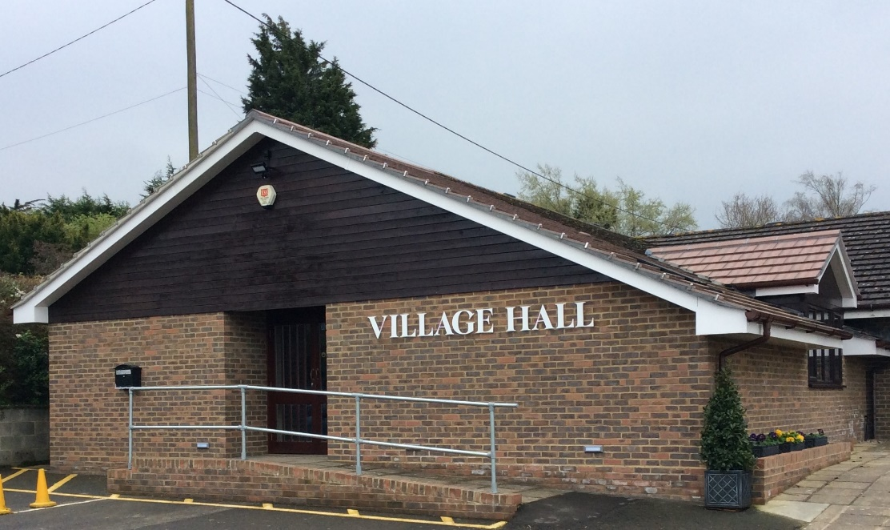

Website: bodlestreetvillagehall.org

Bodle Street Green Village Hall
The Causeway,
Bodle Street Green
Herstmonceux, East Sussex BN27 4UB

Independent Examiner: Mr. Joel Andrews, Sunnyside, Victoria Road, Herstmonceux, East Sussex BN27 4TA

Bankers: CAF Bank Ltd, 25 Kings Hill Avenue, Kings Hill, West Malling, Kent, ME19 4JQ
BODLE STREET GREEN VILLAGE HALL TRUST

TRUSTEES ANNUAL REPORT for 2020

Background History: The Bodle Street Green Village Hall Trust was established by Trust Deed on 19th December 1923 and registered as a charity under number 227875 on 30th January 1964.

Our aims and purposes as a charity:

The Hall Management Committee has the responsibility for fulfilling the main objects of the Trust, as laid out in the Trust Deed, which are to hold the Village Hall and any associated buildings and land for the enjoyment, use and occupation of the inhabitants of the Ecclesiastical Parish of Bodle Street Green irrespective of creed or religious sect for all purposes of instruction, amusement, recreation and social life.

What we planned to do to achieve our charitable objectives:

When planning our activities for the year, the Hall Management Committee have considered the Charity Commission’s guidance on public benefit. In particular, we try to enable residents in the parish and surrounding areas to live out their lives to the full through:

- Providing facilities and activities for people with disabilities.
- Providing community facilities, including broadband, for Parish Council, Parochial Church Council, a wide range of local societies and individuals.
- Encouraging physical well-being with classes for Pilates, short mat bowls, folk dancing and Irish dancing.
- Enhancing local cohesion through the provision of films, stage shows and other entertainment
- Providing reception and catering facilities for a wide range of local users.

What we have achieved and how we affected beneficiaries’ lives:

The usage of the Hall during 2020 was seriously affected by the various periods of lockdown ordered by the UK Government. When allowed by the regulations, the Hall continued to provide a range of services for the Village and local community.

The Bodle Street Women’s Institute was wound up at the end of 2019 and was replaced by ‘The Tuesday Group’ who planned to meet on the second Tuesday of each Month. However only three meetings were held at the beginning of the year. The Bodle Street Green Gardening Club only managed to hold one meeting in the Hall in September 2020. The Villages Luncheon Club only managed to meet twice at the start of the year. The Short Mat Bowls and The Herstmonceux Folk Dancers also stopped their bookings once the first lockdown was announced.

A local Pilates Group meets on Wednesday, Thursday and Friday mornings when ever regulations allowed and some further sessions were conducted on Zoom using the Hall’s broadband. Jiu Jitsu were started during the year and were held whenever regulations allowed. There were very few private hirings for wedding receptions, parties and one-off events organised by local societies due to Government restrictions. The Film Club was able to meet on the last Friday evening of each month for part of the year. During the first lock-down, a local caterer, approved by the Hall Committee, provided take-away meals using the Hall kitchen.

Also because of Government restrictions, Warbleton Parish Council was only able to make limited use of the Hall facilities. Events normally organized by the Bodle Street PCC all had to be cancelled.

During the year, the Village Hall Committee was only able to organized one event namely a Race Night on 18th January 2020:

Financial Review:

The full accounts are detailed on pages 5 - 8 of this report. Due to the restrictions on the use of the Hall, income from Hiring Charges showed a significant decrease to £5,878.00 (£10,574.00 in 2019). General donations totalled £120.00 (£689.00 in 2019) together with a grant of £450.00 from Warbleton Parish Council for the use of the Hall. Warbleton Parish Council also made a further Grant of £450.00 as a contribution towards the cost of ‘white-lining’ the car park. Events held during the year brought in £984.00 and the income from the Film Club was £1,264.00. Interest on Bank funds totalled £9.00. The Hall also received a grant of £10,000.00 from the Government’s COVID-19 relief fund.

Many of the costs associated with the day-to-day running of the Hall and Green continued despite the lack of use and totalled £ 7,449.00 (£8,423.00 in 2019). Maintenance charges were £3,098.00, the major cost being the relaying of the patio. The insurance premium for the year was £986.00 (£976.00 in 2019) with £215.00 spent on professional charges. Repayments on the loan arranged from ACRE in 2016 totalled £4,554. Expenditure on events organized by the Hall Committee amounted to £53.00 (£2,282.00 in 2019).

Total income was £19,156.00 against expenditure of £16,355.00, giving an excess of income over expenditure of £2,801.00

Reserves Policy:

It is Committee’s policy to try and maintain a balance of unrestricted funds which equates to at least three months’ unrestricted payments. This is equivalent to £3,000.00 which is held to smooth out fluctuations in cash flow. To meet the repayment terms under the loan agreement with ACRE, the committee will seek to maintain a further balance of £4,000.00 in unrestricted funds.

Trustees:

The Freehold ‘Holding’ Trustees are Mr. B D Cooper, Mr. B D Gibson MBE & Mrs. Philippa Gentry. Under the terms of the Trust Deed, a Committee, appointed annually, manages the Village Hall and committee members who have served at any time from 3rd May 2019 until the date this report was approved were: Mr. Charles Harding (Chairman), Mr. Geoff Holt (Secretary), Mr. Bryan Gibson MBE (Treasurer), Mr. Barrie Cooper, Mrs. Judith Cooper, Mrs. Philippa Gentry, Mrs. Flowie Georgiou, Mrs. Mary Gibson, Mrs. Margaret Holt, Mrs. Shirley Price MBE, Mrs. Sue Ralph, Mrs. Judy Swan Mrs. Caroline Thompson & Mrs. Pauline Velten. Mrs. Ros Billinghurst (Bookings Clerk) also attends committee meetings as an observer.

Bankers: The Bankers of the Trust are CAF Bank Ltd, 25 Kings Hill Avenue, Kings Hill, West Malling, Kent, ME19 4JQ.

Location: The address of the Hall is Bodle Street Green Village Hall, The Causeway, Bodle Street Green, Herstmonceux, BN27 4UB. The address for correspondence is Mr. Bryan Gibson MBE, Treasurer, “Formiles”, 1 Nursery Lane, Herstmonceux, BN27 4TP.

The Trustees Annual Report was approved by the Hall Management Committee and signed on their behalf by Mr. Charles Harding, Committee Chairman.

________________________________________________________ Date: 30th June 2021

Annual Financial Report

of

BODLE STREET GREEN
VILLAGE HALL TRUST FUND
Charity Registration Number: 227875

For the year ended 31st DECEMBER 2020

CONTENTS

Page

Summary of financial receipts and payments 5

Statement of assets and liabilities (receipts & payments) 6

Notes to the Accounts 7 - 8

Report of the Independent Examiner 9

BODLE STREET GREEN VILLAGE HALL TRUST FUND
(Registered Charity No: 227875)

Summary of Financial Receipts & Payments

The financial effect of our activities during the year can be summarised as follows:

Unrestricted Funds Total 2020 Total 2019
Income from: £ £ £
Donations 120 120 389
Charitable activities 8,127 8,127 19,121
Inland Revenue Refund 0 0 0
Grounds 0 0 300
Interest 9 9 16
Grants 10,900 10,900

Total Received £19,156 £19,156 £19826 Note 2

Expenditure on:
Cost of raising funds 8,488 8,488 11,788
Charitable costs 3,313 3,313 1,202
Capital expenditure 0 0 408
Loan Repayments 4,554 4,554 4,554

Total paid £16,355 £16,355 £17,952 Note 3

Reconciliation of funds:

Net Income
or (net) expenditure 2,801 2,801 1,874

Bank accounts at 1 January 12,013 12,013 10,139

Bank accounts at 31 December £14,814 £14,814 £12,013

BODLE STREET GREEN VILLAGE HALL TRUST FUND
(Registered Charity No: 227875)

Statement of Assets and Liabilities (Receipts and Payments presentation)

 | General Fund 2020 | General Fund 2019 | Notes
 | £ | £
Assets
Bank current account | 193 | 155
Bank deposit account | 14,497 | 11,764
Petty Cash | 123 | 93
Bank & Deposit Accounts | £14,814 | £12,012
Debtors | 0 | 0
Land & Buildings |  |  | 4
Hall at 31/12/19 | 168,862 | 171,796
Add Extension Build | 0 | 0
Less Depreciation | 2,934 | 2,934
Value at 31/12/20 | 165,928 | £168,862
Fixtures & Fittings
Value at 31/12/18 | 1,013 | 4,481 | 4
Add 2020, expend | 0 | 408
Less Depreciation | 1,013 | 3,876
Value at 31/12/20 | 0 | 1,013
Total Assets | 180,742 | £181,887
Liabilities
ACRE Loan - outstanding | 2,645 | 7,199 | 6
Total Liabilities | 2,645 | 7,199
Net Assets – 31/12/20 | £178,097 | £174,663

This Financial Report for the year ended 31st December 2020, including the notes following, was approved by the Village Hall Management Committee and signed on its behalf by Mr. Bryan D Gibson MBE, Treasurer.

B D Gibson
___________________________________________

Date: 30th June 2021

BODLE STREET GREEN VILLAGE HALL TRUST FUND
(Registered Charity No: 227875)

Notes to the Financial Report

- The financial statements of the Trust have been prepared in accordance with the Charities Act 2011 using the Receipts and Payments basis.

- Analysis of total received

 | General Fund 2020 | All Funds 2019 | Notes
 | £ | £
Hiring Charges | 5,878 | 10,574
Donations – General | 120 | 689
Gift Aid recoverable | 0 | 0
Events | 984 | 6,377
Interest | 9 | 16
Film Club | 1,264 | 2,170
Grants | 10,900
Total Received | 19,156 | 19,826
3 Analysis of total paid

 | General Fund 2020 | All funds 2019 | Notes
 | £ | £
Direct Charitable Expenditure
Hall Costs | 7,449 | 8,423
Insurance | 986 | 976 | 5
Events | 53 | 2,282
Charitable Donations | 0 | 0
Fixtures & Fittings | 0 | 408
Film Club | 0 | 0
Total Charitable Expenditure | 8,488 | £12,196
Management & Administration
Legal & Professional | 215 | 147
Loan Repayment | 4,554 | 4,554 | 6
Hall & Grounds Maintenance | 3,098 | 1,055
Total | 7,867 | £5,756

4. TANGIBLE FIXED ASSETS

Land & Buildings:
In the original Trust Deed dated 19th December 1923 paragraph 4 states: “If and when the Village Hall is no longer required or used for the benefit of the inhabitants aforesaid or for the purposes hereinbefore specified or some of them this present grant shall at the expiration of Two years from the cessor of such user thereupon become annulled and of no effect and the said land shall revert to and become the property in fee simple of the Donor or other the person or persons who may then be the absolute or reversionary absolute owner of the said field numbered 36 thereinbefore mentioned PROVIDED ALWAYS that on the happening of such an event the Trustees their heirs successors and assigns shall have the right within reasonable time after the expiration of such two years to sell and remove or take away the said Village Hall and Buildings from the said land doing no more damage than is necessary in the act of such removal.”

The land on which the Hall and Green are situated is, therefore, held in trust and is not valued. In the opinion of the Trustees, given the restrictions imposed by the Trust Deed, it is unrealistic to value the Hall at market value. Therefore, the buildings are shown in the balance sheet at cost less depreciation. Under the terms of the National Lottery grant awarded in 1998 to build the new Hall, the hall must be depreciated over 80 years. The new Hall, built in 1998, cost £150,170.00 to build which over 80 years gives an annual depreciation of £1,877.00. The residual value of the Hall at the end of 2015 was £116,126.00. Building the extension in 2016 cost £64,472.00 which will now be depreciated over 61 years (The balance of the 80 years since 1998). This increases the annual depreciation by £1,057.00 giving a total annual depreciation for the building of £2,934.00.

Fixture & Fittings: Depreciation is provided on all tangible fixed assets at rates calculated to write off the cost of each asset evenly over its expected useful life, which for Fixtures and fittings is 4 years. The balance at the end of 2019 of £1.1013 has been fully depreciated in 2020.

- INSURANCE

The Hall and its contents are insured with Allied Westminster (Insurance Services) Ltd under a ‘VillageGuard Village Hall’ Insurance Policy. Following on from the completion of the extension in 2016, the Hall was re-valued for insurance purposes and is currently insured for £597,525.00. For insurance purposes, the contents of the Hall are insured for £27,518.00.

- ACRE LOAN

A successful application for a loan was made to ‘Action with Communities in Rural Areas’ (ACRE) and agreed on 22nd April 2016 and a cheque for £22,000.00 was received on 24th June 2016. This is to be repaid over 5 years (20 Quarterly payments) with an interest rate of 1.32%. The first repayment installment was paid on 15th October 2016 with a final payment in July 2021.

- TRUSTEES REMUNERATION AND EXPENSES

The Trustees received neither remuneration nor expenses from the charity. Some payments were made to Trustees during the year for reimbursement of expenses incurred on behalf of the Trust.

BODLE STREET GREEN VILLAGE HALL TRUST FUND

INDEPENDENT EXAMINER’S REPORT ON THE ACCOUNTS

Independent Examiner’s Report to the Trustees and Management Committee of the Bodle Street Green Village Hall Trust (Charity Registration Number: 227875) for the year ended 31st December 2020.

This is my report to the Management Committee of the Bodle Street Green Village Hall Trust, on the annual report for the year ended 31st December 2020 set out on pages 9 and 10.

Respective responsibilities of Trustees and Examiner
The committee members are responsible for the preparation of the annual reports. The Management Committee consider that an audit is not required for this year under section 144 of the Charities Act 2011 (“The Charities Act”) and that an independent examination is needed.
It is my responsibility to
- Examine the accounts under section 145 of the 2011 Act;
- Follow the procedures laid down in the General Directions of the Charity Commissioners section 145(5)(b) of the Charities Act; and
- State whether particular matters have come to my attention.

Basis of Independent Examiner’s Statement

My examination was carried out in accordance with the General Directions given by the Charity Commission. An examination includes a review of the accounting records kept by the charity and a comparison of the accounts with those records. It also includes considering any unusual items or disclosures in the accounts and seeking explanations from the trustees concerning any such matters. The procedures undertaken do not provide all the evidence that would be required in a full audit, and consequently no opinion is given as to whether the accounts present a ‘true and fair’ view and the report is limited to those matters set out in the statement below.

Independent Examiner's Statement

In connection with my examination, no material matters have come to my attention which gives me cause to believe that in, any material respect:
- accounting records were not kept in accordance with section 130 of the Charities Act or
- the accounts do not accord with the accounting records
I have come across no other matters in connection with the examination to which attention should be drawn in order to enable a proper understanding of the accounts to be reached.

Examiner’s signature ………………………………………………………………………………………………………

Examiner’s name capitals Mr. JOEL ANDREWS

Date: 9th May 2021. Relevant professional qualification(s) or body (if any) ……………………………….

Examiner’s Address: Sunnyside, Victoria Road, Herstmonceux, East Sussex BN27 4TA

